Enterprise Sales Application Part II

Elbio Iseas, Minh Thien Tran, Neil Goldstein, Rob Fassett

DBM/460

October 10, 2016

Daniel McDonald

**Introduction**

The Enterprise Sales Application will help querying the data in the database in a fast and efficient way to allow analyze this information by giving decision makers the tools to make the write decisions for benefit of the company and to stay competitive in the market. This paper will discuss the advantages and disadvantages of an enterprise data warehouse, the ETL process, an ad-hoc reporting strategy, and a data mining strategy.

**Advantages and Disadvantages of an Enterprise Data Warehouse**

An enterprise data warehouse is a centralized database comprised of data from many disparate sources. Disparate sources are sources that are different in kind and don’t allow for easy comparison. However, using tools to extract the data, transform it, and load it in to the data warehouse allows for a more in-depth look at all the data and allow critical business decisions to be made. This is one of the largest advantages of a data warehouse: the ability to see all the data from all the sources in one.

As the data is transformed for the data warehouse, the data is also cleansed. Meaning that all the data in the warehouse has been organized and all redundancies are eliminated. This is another advantage of a data warehouse: clean data. Additionally, with all the data being transformed, cleansed, and made available in one area, the data is centralized making it available for people in many different locations to analyze the data to make critical decisions.

The disadvantages of a data warehouse can be almost directly related to the advantages. While the data can be transformed and cleansed, this process can take years depending on the volume of data. Compatibility will also be a factor in the transformation process if the data sources are dated or there are too many constraints. Maintenance of the data warehouse will also be cumbersome with how much data is stored. Maintenance includes not only the data itself, but co-location costs, servers, and other technologies to support the data warehouse.

**ETL Process for Loading Data into the Database**

The process of Extraction Transformation and Loading (ETL) data for Lafleur Trading Company uses SQL Server Data Tools SSIS to import data from an Excel spreadsheet. In this file, there are the data for the sixteen tables of the database that the Enterprise Sales Application uses. The first step on the ETL is the “Data Extraction” (Ponniah, 2010) for identifying what are the data sources, platforms, and what files. The second step is “Data Transformation” (Ponniah, 2010) where data is checked for errors, customized, and getting ready for loading. The third step is “Data Loading” (Ponniah, 2010) which will insert that in the tables after deciding what will be the frequency of loading, and the time of the day. The following images show the Import and Export Wizard being used to load data into the data warehouse.

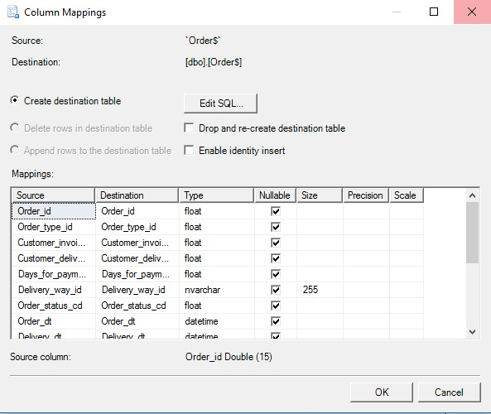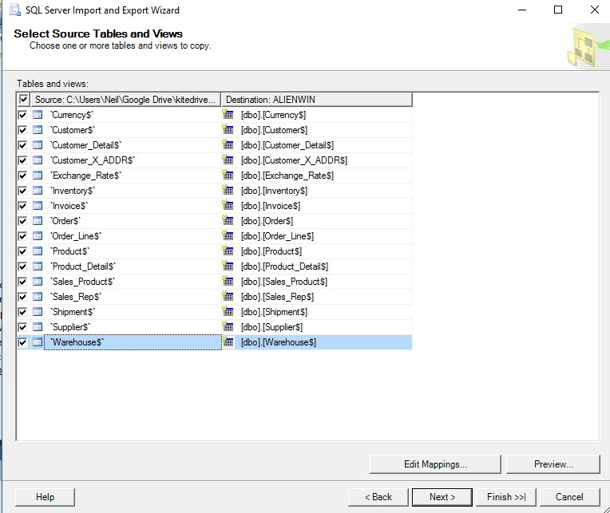

**Reporting Strategy Designs**

The client will need robust reporting applications to get useful information out of the data warehouse. Several reporting strategies will be proposed to cover this. Each of these strategies will be explained here. These strategies will include drill down analysis for moving from parent to child attributes, and drill across analysis for moving across dimensions in the data warehouse. A graphical dashboard will be designed for the users with easy to understand point and click, menus, and radio buttons for producing useful results.

**Ad-Hoc**

Ad-Hoc reporting is sometimes referred to being *on the fly*, or, something that does not already exist in the system and can be defined using OLAP dashboards (Rouse, 2010). Usually a point-and-click interface is presented to the user, allowing them to create the ad-hoc report. This is intended to be a one-time use report, but can frequently be saved to be reused as a report or a template for future reports. Sometimes an ad-hoc report can be used to drill deeper into a static report (explained below)

**Static**

Static reporting can be referred to as a *canned* report, or a report that is predefined without options, and does not update automatically as data changes. Static reports cannot be modified *on the fly* but just displayed.

**Parameter-Driven**

A parameter-driven report is a report where the user can customize results according to their needs by specifying parameters and specific operations (Computer Hope, 2016). Parameter driven reports are mostly defined and saved as a framework, and then run with specifics depending on the desired results.

**Data Mining Strategy**

Data mining will be used to help improve business management and operations in several ways. The first strategy is called affinity analysis (also called basket analysis), which helps to determine the correlation of activities between individuals or groups. In terms of Lafleur’s business, it will help determine purchase/order behaviors of customers. This will help the company develop strategies for upselling, cross-selling, loyalty programs, discounts, and product promotions. Data mining can also be used in sales forecasting to predict future sales. The company will be able to compute various cash flow projections and decide how much capital is needed to expand into other regions (Patel, n.d.).

Merchandise planning is another area where data mining will be used. Information gleaned from the data warehouse will help Lafleur determine what products customers want, how to price them, and what kind of merchandise competitors offer. Merchandise planning will also help the company keep a good balance of products in stock.

Market segmentation is an especially important strategy that utilizes data mining. Customers will be segmented into various segments such as buyer type, buyer location, product types, and other meaningful dimensions. Segmentation will help Lafleur understand its competition and customize its products and promotions to come out on top.

References

*Advantages and Disadvantages to Using a Data Warehouse | IT Training and Consulting – Exforsys*. (2016). *Exforsys.com*. Retrieved 5 October 2016, from http://www.exforsys.com/tutorials/data-warehousing/advantages-and-disadvantages-to-using-a-data-warehouse.html

Patel, N. (n.d.). *10 ways data mining can help you get a competitive edge*. Retrieved from https://blog.kissmetrics.com/data-mining/

Ponniah, P. (2010). *Data warehousing fundamentals for IT professionals* (2nd ed.). John Wiley & Sons, Inc.

Poolet, M. (2009). *Seven Steps for Successful Data Warehouse Projects*.*Sqlmag.com*. Retrieved 4 October 2016, from http://sqlmag.com/database-administration/seven-steps-successful-data-warehouse-projects

Rouse, Margaret. (2016). *What is ad hoc analysis? - Definition from WhatIs.com*. (2016).*SearchBusinessAnalytics*. Retrieved 10 October 2016, from http://searchbusinessanalytics.techtarget.com/definition/ad-hoc-analysis

*What is Parameter-driven?*. (2016).*Computerhope.com*. Retrieved 10 October 2016, from http://www.computerhope.com/jargon/p/pa